**Prototype Concept & Feature Description   
Instagram**

**User Control**

* No user login or sign-up is required, and hence no user session will be supported.
* User has to upload data every time they want to visualize.
* No user authentication is provided to verify if user is uploading his/her data only.

**Admin Control**

* Admin can manage the PriOSS repo without the maintenance window.

**Web-app**

* Web-app should be supported on popular browsers – Chrome, Safari, MS Edge, Firefox.
* User can use the website in English only (v1). With Google translator (in chrome), website should be available in language of user’s choice.
* If feasible, the web-app could also be implemented as mobile-app (Android, iOS).
* The hosting web-server should support scalability.
* Visualization dashboard should be created and shown with minimal latency.

**Data upload**

* Data download instructions be easily understandable.
* Upload data should be possible irrespective of size of data.
* Once data is uploaded, TET will choose portions of data to be displayed, rather than asking the user to choose parts of data to be visualized.
* Information about the offline working of web-app should be shown clearly, using either a pop-up or displaying a note after the data is uploaded by the user.

# General Navigation Menu

* Collapses to the side, hiding the texts and only showing a narrow column with Icons for the menu items
* “Home”, “About”, “Contact” & “Remove data-download” menu items.

# Instagram Navigation Menu

* Menu changes after switching to the Instagram Dashboard
* “Home”, “About”, “Contact”, “Instagram Dashboard”, “Visualizations”, “Data Security” and “Rights” menu items.

# Dashboard

There will be four different sections for our application leading to different information for the user.

First section will be about “**PriOSS-Instagram**”:

* What Data is collected?
* What can PriOSS do?
* Visualization (It will be a hyperlink which will take user to visualization page)
* Data Security (It will be a hyperlink which will take user to Data security page)
* Rights Page (It will be a hyperlink which will take user to Rights page)
* “Frequently Asked Questions” containing tiles that each contain one question, like
  + “For what purposes does Instagram use my data?”
    - Click leads to Purposes-Page
  + “What rights do I have in regard to my personal data?”
    - Click leads to Rights-Page
  + “How can I erase my personal data from Instagram?”
    - Click leads to Erasure-Helper
  + etc.

Each tile links to an information page that educates the user about the respective question.

Dashboard will look like –

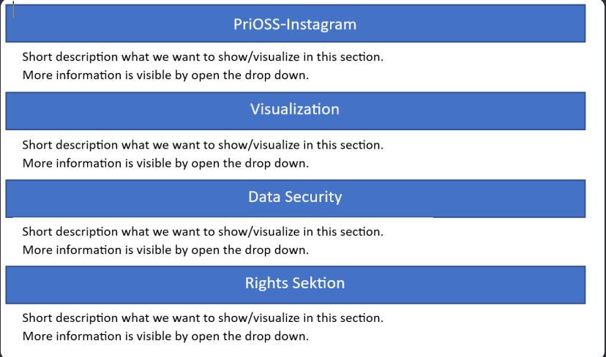

Second section will be about “**Visualization**”:

It will consist of 12 (tiles) topics for visualization –

* Advertisements

1. Advertisers that use our information

To be visualized in List format.

1. Advertisements viewed

To be visualized in List format.

Mostly viewed companies will be shown in a bar chart.

Filters-

* By Company
* By Year/Month
* Comments
* Shows Comments on post

To be visualized in List format.

* Shows Comments on reels

To be visualized in List format.

Filters-

* By users
* By Year/Month
* Contacts

To be visualized in alphabetical List/Table format.

Filters?

* By numbers
* Device information
* Shows through which devices Instagram has been used.

To be visualized in List format.

Filters-

* By Year/Month
* Followers and following
* Shows blocked accounts
* Shows follow requests you have received
* Shows Followers
* Shows Following
* Shows Pending follow requests
* Shows Recently unfollowed accounts
* Shows Restricted accounts

To be visualized in horizontal bar graph. Then, the list will be displayed for all the entries.

Filters-

* By Year/Month
* By Followers
* Information about you
* Shows Ads interest

To be visualized in List format.

Filters-

By Year/Month

* Shows Account based information

To be visualized in List format.

Filters-

* By Year/Month
* By Alphabetical order
* Data

1. Likes

* Shows likes on comments
* Shows likes on posts

To be visualized in horizontal bar chart.

Filters-

By users

By year/month

1. Messages

* Shows Inbox messages
* Shows message requests

To be visualized in No. of interactions. Intractable – expand to show names with whom exchanged messages.

Filters-

Sort messages old→ new or vice versa.

By Year/Month

1. Media

Guidelines how to see your posts, reels, stories, archived posts, recently deleted posts

* Login and account creation
* Shows login activity
* Shows logout activity
* Shows Last known location
* Shows sign up information
* Shows accounts privacy changes

To be visualized in 2-D timeline.

Filters-

By Year/Month

* Personal information
* Shows personal information
* Shows Professional information
* Shows account information
* Shows linked meta accounts
* Shows Profile changes

To be visualized in one information box.

* Searches

1. Account searches
2. Tag searches
3. Word or Phrase searches

To be visualized in 2-D timeline and Horizontal bar chart.

Filters-

By Year/Month, By alphabets (Usernames)

* Shopping

To be visualized in list format.

Filters-

By year/month

* Your topics

To be visualized in list format.

Filters-

By year/month

Visualization will look like –

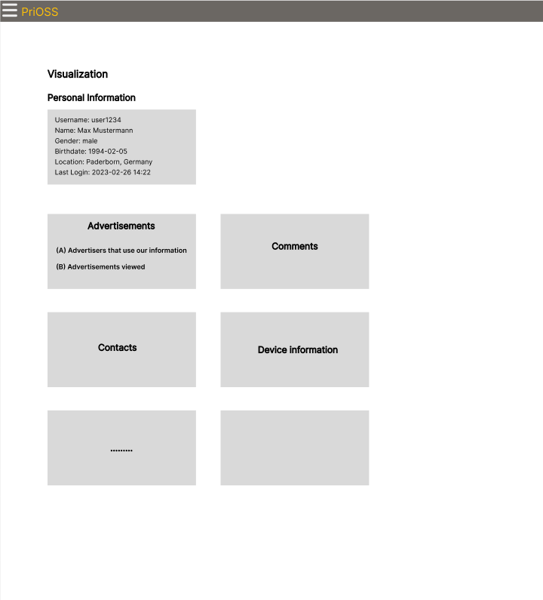

Third section will be about “**Data Security**”:

This page will contain questions that will answer the following:

* How to improve privacy?
* Privacy Settings Center
* Shows recommendations on where what settings can be changed for the respective services, possibly realized as an interactive survey.
* Contains Alert if many inferences are present in the Instagram data since this can be a sign of active Facebook linking. The user should be able to disable the alert if they do not find it helpful or it does not apply to them.
* Purposes
* Explains for what purposes Instagram says that it uses your data.
* Show purposes related to data sharing with third-party services.
* Erasure-Helper
* Explains what options one has to erase data from Instagram.

Data Security will look like –

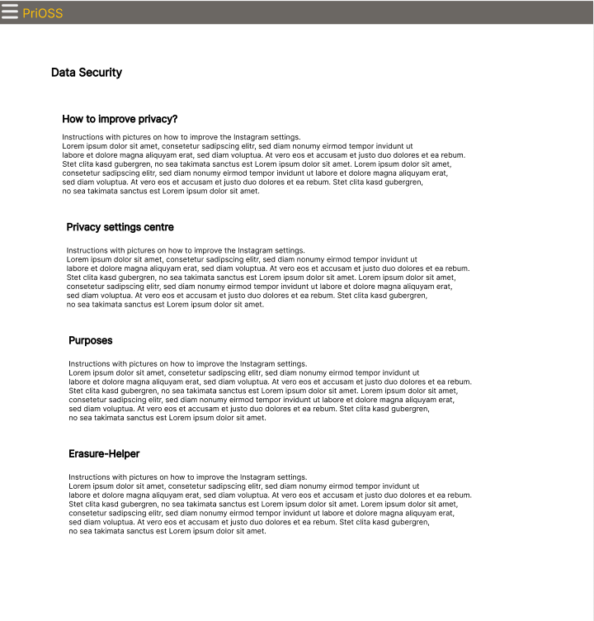

Fourth section will be about “**Rights Page**”:

* Explains in simple terms what rights the GDPR grants users in regards to your personal data. Links to the global GDPR page for more information.
* Shows instructions on how to:
* Delete data
* Withdraw consent
* Alter data

Rights will look like –

